**Bug ID:** 5

**Bug Summary:** Negative values are accepted in the discount filed, discount can be set to – values, for example -50%, which actually increases prices

**Environment/URL:** https://qwallity-exam.onrender.com/

**Operation System:** Windows 10 x64

**Version**: 1

**Browser:** Chrome 109.0.5414.120

**Submit Date:** 28/01/2023

**Reporter:** Arman Egiazarian

**Steps to Reproduce:**

1. Open the Qwallity app
2. Log in as an admin user
3. Click on the username on the upper right side
4. Click on change discount button
5. Input negative discount percentage
6. Click change discount

**Expected Result:** Negative values should not be accepted.

**Actual Result:** Validation message is displayed and results are accepted

**Screenshot/video:** Screenshot:

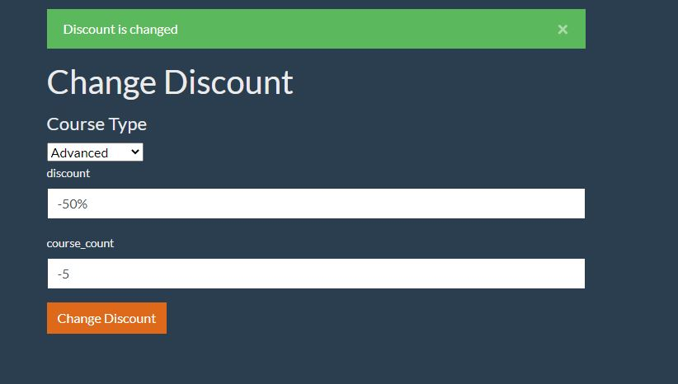

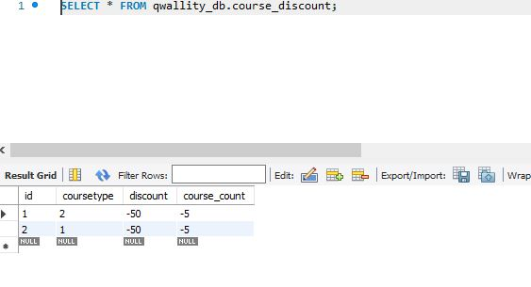

**Notes:** -

**References: -**

**Severity:** High